1. Concept: Electronics kya hota hai?
Electronics = electric signals ko control karna (ON/OFF, amplify, filter, convert).
Isme components hote hain jaise resistor, capacitor, diode, transistor, ICs.

2. Short Definitions (Basic Components)
- Resistor → Current ko limit karta hai.
- Capacitor → Charge store karta hai.
- Diode → Current ko ek hi direction me flow hone deta hai.
- Transistor → Switch + Amplifier (control device).
- IC (Chip) → Multiple circuits ek package me.

Resistor
Resistor = current ko control/limit karne wala component.

Short & Simple Definition
Resistor current ko kam karta hai taaki circuit safe chale, overheating na ho, aur components damage na hon.

Use Cases + Syntax + Example
- LED ko protect karna
- Voltage divide karna
- Noise filter karna
- Current limit karna
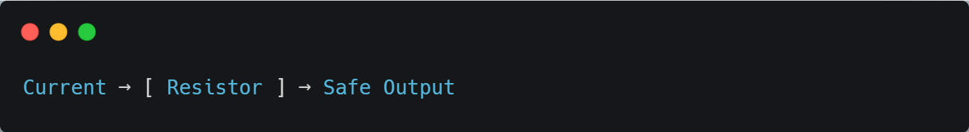
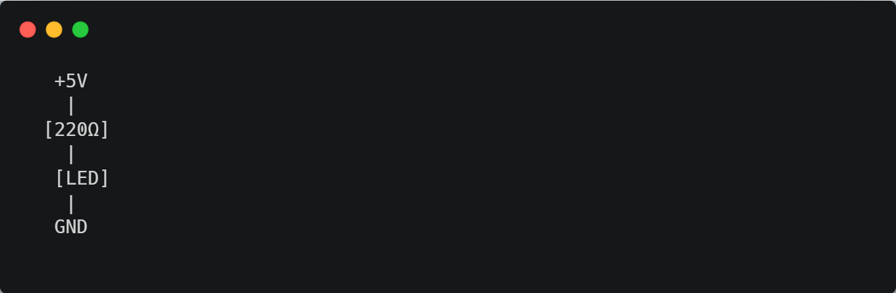

✔ Overcurrent se protect karta hai
✔ LED ko safe rakhta hai
✔ Voltage thoda drop karta hai
✔ Smooth output deta hai

(Series Concept)
Series me component ka end NEXT component ke start se jodte hain.
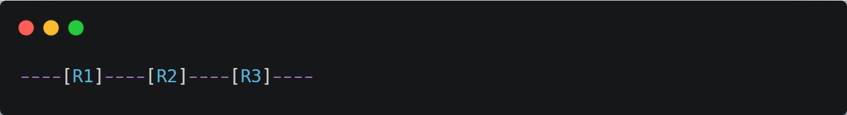
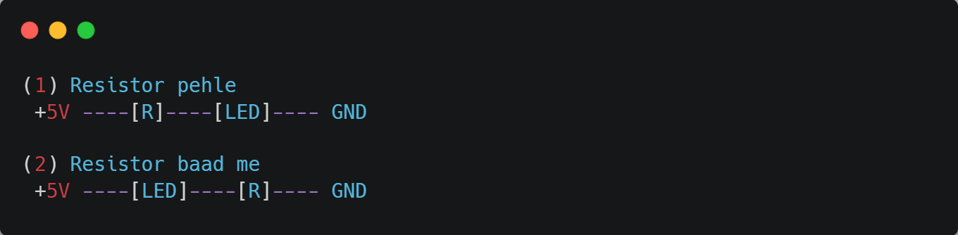
Dono me current same hai.

(Parallel Concept)
Parallel me dono resistors ke dono ends SAME points se connect hote hain:
